**Assignment 2b**

**CS4610**

**Michael Rallo – msr5zb – 12358133**

**3/13/2017**

**Assignment 2b**

The *purpose* of this assignment was to familiarize ourselves with manipulating objects in space. We were to learn how to manipulate the object via rotation, translation, as well as using different perspectives/views to see how our view of the object changes.

Objectives:

1. On top of Assignment 2a, define a virtual camera in a 3D virtual scene, specifying its position, orientation and field of view.
2. Using your graphical user interface (GUI) such as GLUT or equivalent, together with the mouse and keyboard, interactively perform the following tasks:
   1. Translate the model / camera in X, Y and Z directions.
   2. Rotate the model / camera around X, Y, and Z axes.
   3. Rotate the model /camera according to the moving direction and distance of the mouse.
   4. Zoom in and zoom out view of the model.

Approach: I created a function that would load in the OBJ file data into global arrays to be rendered later on. In order to ensure that the object was displayed correctly, I kept track of the min/max positions of the object and transitions/scaled it to fit in the view. By default I am using the projection display mode of which the field of vision is set to 55. Note the scalar function helps keep everything in view by default. I also added in keyboard functions in order to swap between different objects and display modes. Translation and camera views manipulation was also added in. Translating the model was easily done, I simply translated in space ‘x’ amount based on the key inputted. In order to rotate the model, I kept track of the onclick cords (before) and computed the new cords of the mouse as it dragged – from which I rotated the object accordingly. To zoom, I adjusted the camera’s field of view. All of these actions and methods will be discuessed in further detail below.

**The Header File (OpenGLDefaults.h)**

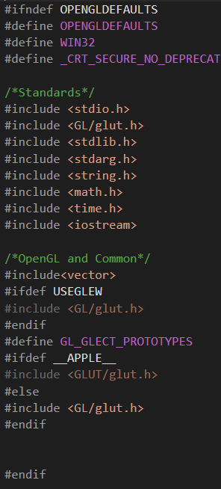First and foremost, I have decided to include a header file to be used for this assignment’s, as well as future assignments’, libraries. Note this file include OpenGl basic libraries, as well as printing for debugging and math for easy/complex calculations.

**Main**

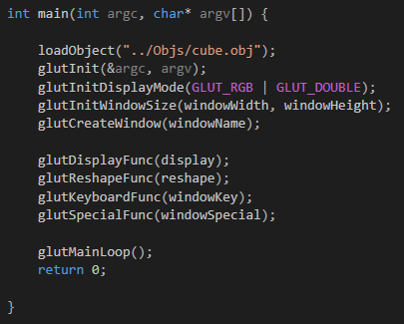

Our main function is similar to that from Assignment one. Note by default we load in the cube object file.

**Global Variables**

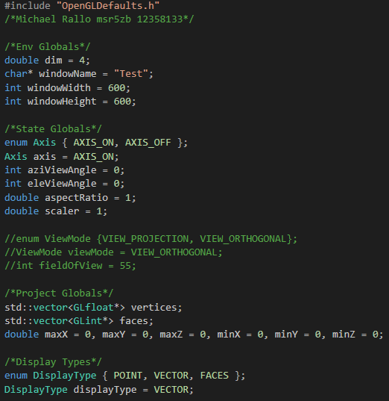

For this assignment, I will be using global variables for the window and view values. I will also be adding in an XYZ Grid in order to “see” the object more clearly in 3d space. Vertices and Faces from the file will be loaded into the vertices and faces vectors. The DisplayType will keep track of how we will be displaying our object.

**Drawing the XYZ Grid (Extras)**

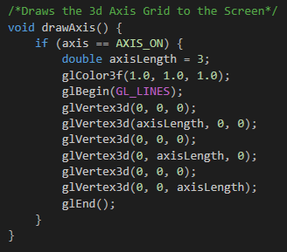

This is a simple function to draw a grid at the origin of our view in order for us to see the object more clearly. This can be toggled on and off with the “i” key. By default, it is on.

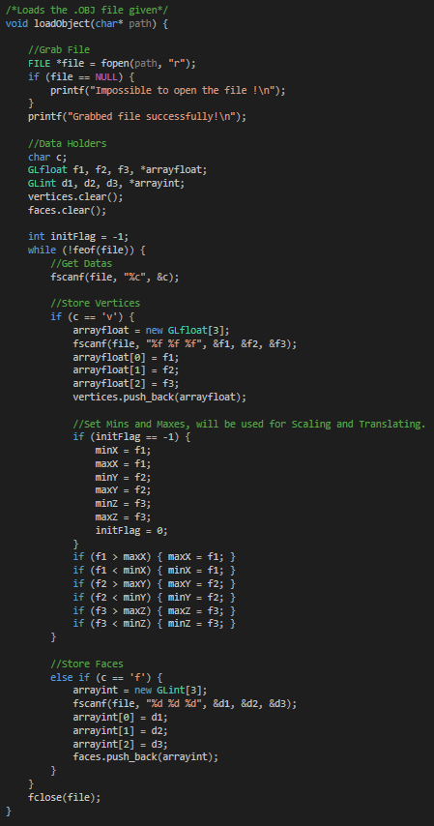**Loading the File (loadObject)**

This function take the object the as a parameter and sets our global vertices and faces variables with the data the OBJ file contains. This function also sets the min/max values that will be later used for scaling/transitioning our object.

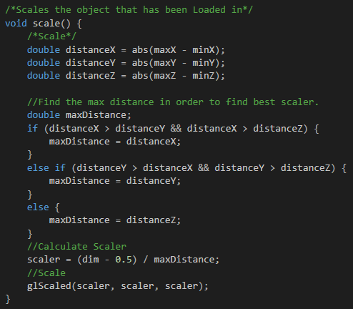**Scaling (Scale)**

This scale method finds the greatest distance between the X, Y, and Z axis and uses that as a scaler for this Object. The reason we use the longest distance is so that we can scale everything equally whilst still being in our view.

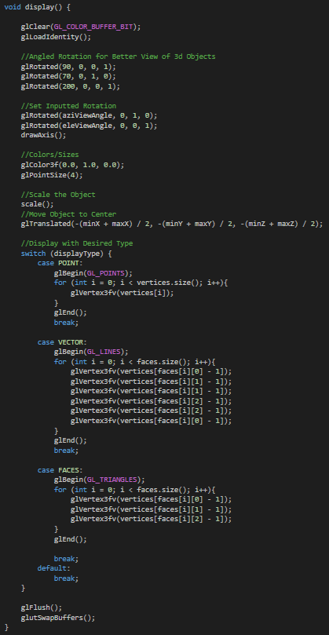**Display**

Our display function is pretty simple. We start by rotating the object slightly in order to achieve the best starting position for our object in 3d space. Note we also add in adjusted rotation angles (azi and ele angles).

Our glTranslated function takes the midpoint of our object’s X, Y, and Z points in order to translate our object to the origin of our view.

From there, depending on the set displayType, the object will be displayed accordingly (default is set to vectors because it looks really cool).

**Reshape**

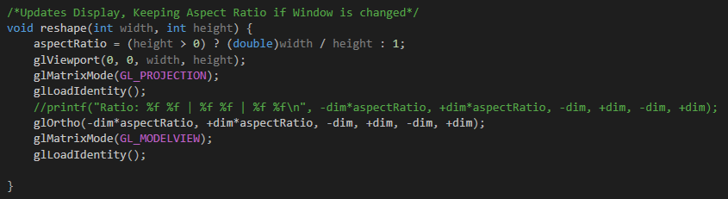

Our reshape function is very basic. It sets our Ortho view while also maintaining our aspect ratio.

**Keyboard Input**

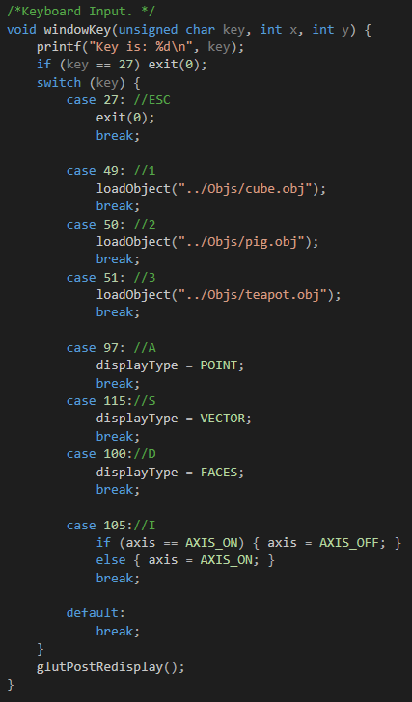The Esc key simply exits our program.

Keys 1, 2, 3 swaps the object we will be displaying (Cube, Pig, Teapot respectively).

Keys A, S, D changes the display type of the object (Point, Vector, and Faces respectively).

Our I key toggle the XYZ grid on/off.

**Arrow Keys and Object Rotation**

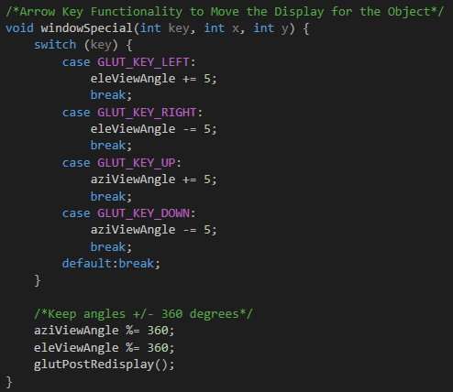

Pushing the arrows keys will rotate our objects around in space. Note both the grid and our object moves simultaneously because we did not pop/push our matrices.

**The Output**

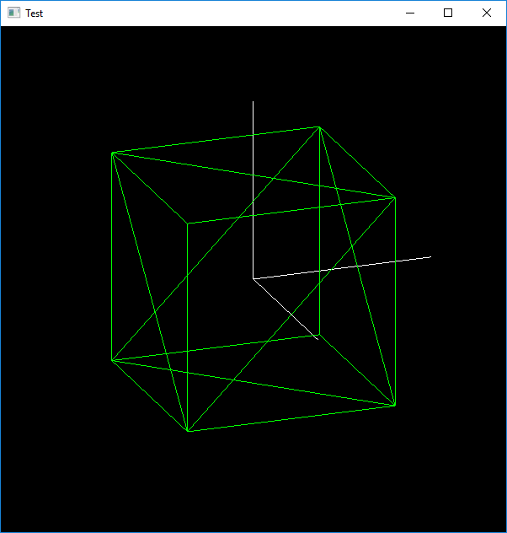

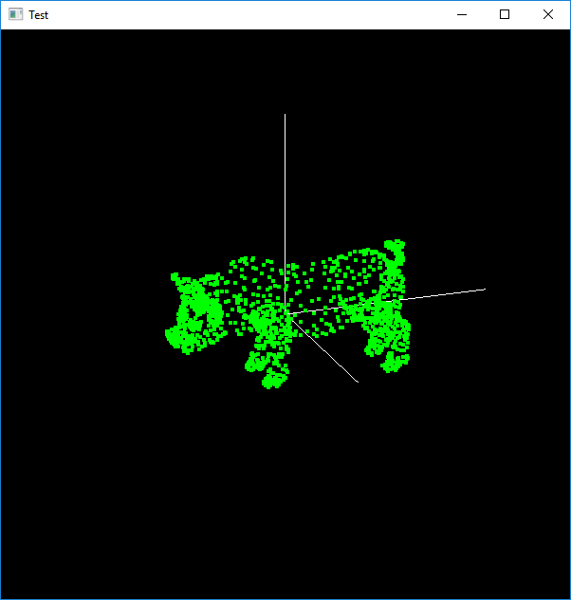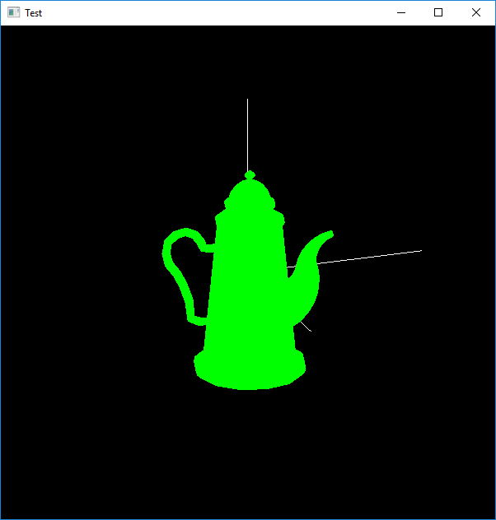

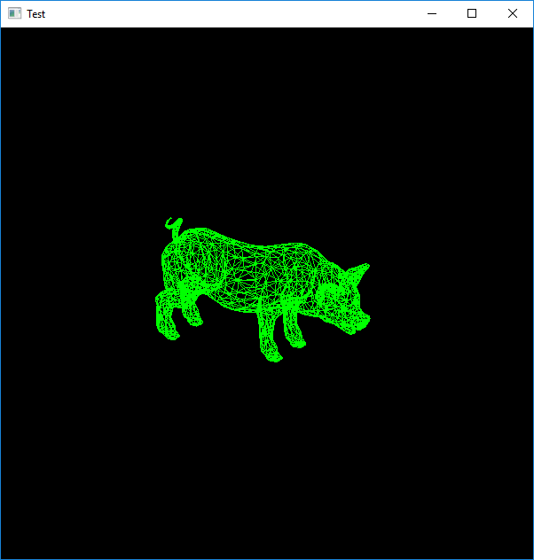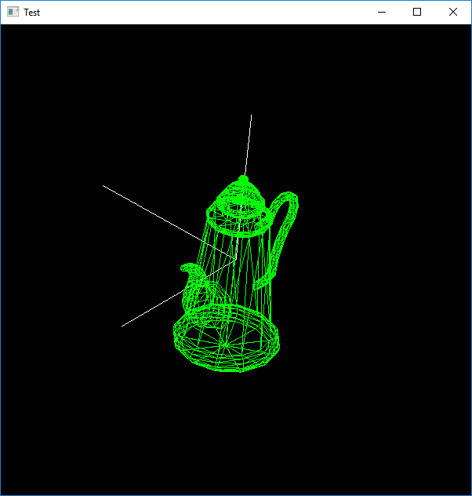The following are samples of outputs. Note how the grid helps us see how the objects was centered and how the points, vectors, and faces are displayed. Also notice how we can move our objects in space to get a better perspective of how the object is built.

I did not bump into any remaining issues. Possible future additions our be to instead of using the arrow keys to rotate our object, use the mouse dragging abilities.